Meaghan Murphy  
**Partner**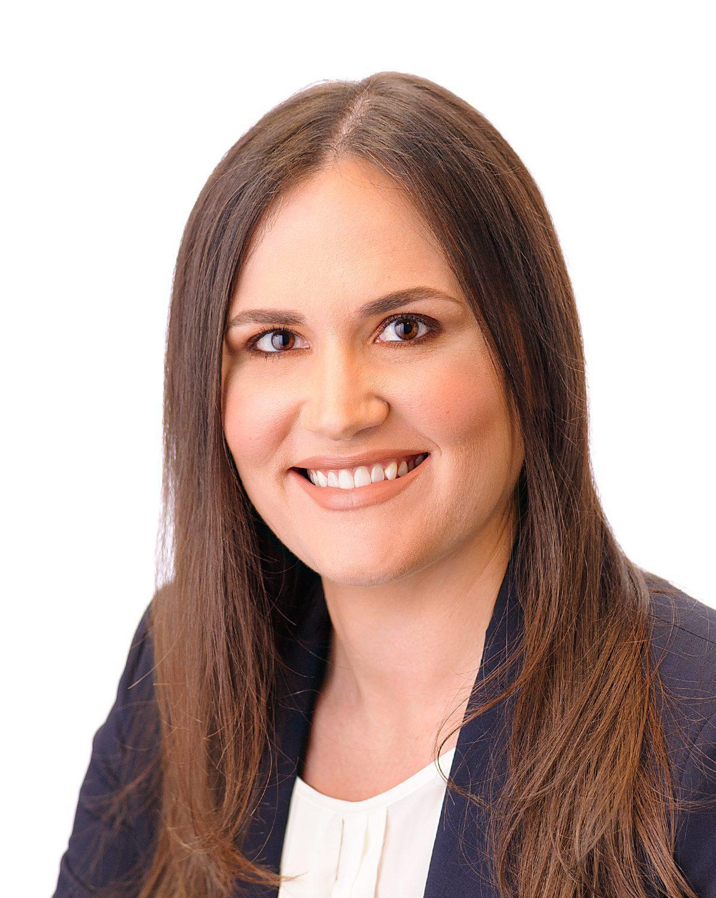

**Bankruptcy and Restructuring, Commercial Litigation, Creditors’ Rights, Receiverships and Assignments**

Office: 305.358.6363, Direct: 305.722.7566, Fax: 305.358.1221

Email: mmurphy@melandbudwick.com

**About Meaghan Murphy**  
Meaghan Murphy, a partner with Meland Budwick, P.A, focuses her practice on bankruptcy and complex commercial litigation. In her bankruptcy practice, Meaghan represents business debtors, bankruptcy trustees, creditors and creditors committees in a variety of Chapter 7 and Chapter 11 proceedings, with an emphasis on representing commercial landlords and tenants. Meaghan’s strong understanding of commercial leasing and its treatment in bankruptcy has benefited both commercial landlord and tenant clients, including in helping successfully guide multiple retail debtor-tenants in distressed commercial leasing situations through Chapter 11, resulting in millions in relief. Meaghan also regularly pursues and defends adversary proceedings, including fraudulent transfers and preference matters, as well as represents clients in state court insolvency and receivership proceedings, including assignees and creditors in assignments for the benefit of creditors and receivers in receiverships.

Meaghan also handles a wide variety of complex commercial litigation matters for clients, including pursuing and defending commercial foreclosure matters as well as contract and business tort claims. Meaghan frequently handles post-judgment asset recovery in matters involving high net worth judgment debtors and financial fraud, and has successfully obtained receivers in post-judgment proceedings, including over the assets of individual judgment debtors. In addition, Meaghan assists in due diligence review for investor clients purchasing distressed loans and assets and provides necessary litigation representation following purchase.

Meaghan is committed to giving back to the community. She is an active member of the Junior League of Miami and has provided pro bono representation and assistance to Chapter 7 debtors, individuals in residential foreclosure proceedings, and individuals with major health concerns such as HIV and AIDS with immigration, Social Security, and public benefits matters.

**Education**

* University of Miami School of Law, J.D.,  *magna cum laude,* 2012
  + Dean’s List
  + Order of the Coif
  + Psychology, Public Policy & Law Journal, Managing Editor (2011-2012)
* University of Idaho, B.S., 2008

**Bar Admissions**

* Florida
* U.S. Court of Appeals for the Eleventh Circuit
* U.S. District Court, Southern District of Florida
* Florida Southern District Bankruptcy Court
* U.S. District Court, Middle District of Florida
* Florida Middle District Bankruptcy Court

**Memberships**

* Bankruptcy Bar Association for the Southern District of Florida
  + Second Vice President, 2024-present
  + Secretary, 2023-2024
  + Treasurer, 2022-2023
* Member, International Women’s Insolvency & Restructuring Confederation
* Member, American Bankruptcy Institute
  + 2024 Class of 40 Under 40
* Member, Federal Court Practice Committee of The Florida Bar

**Awards/Rankings**

* American Bankruptcy Institute, Class of 40 Under 40, 2024
* Florida Legal Awards, “Dealmaker of the Year” finalist, 2024
* Miami-Dade Bar Young Lawyers Section, 40 Under 40 Award recipient, 2024
* The Best Lawyers in America, 2024

**Publications and Panels**

* Co-author, “*An Unlimited Reach-Back Period When IRS Is Triggering Creditor?*” American Bankruptcy Institute, January 2017
* Co-author, *“Rejection of Songwriter Publishing Agreements in Bankruptcy”* American Bankruptcy Institute, January 2019

**Representative Matters**

| Practice Area | Representative Matters |
| --- | --- |
| Bankruptcy | Serves as proposed bankruptcy counsel for the Committee of Unsecured Creditors of Eiger Biopharmaceuticals, Inc., a commercial-stage biopharmaceutical company that filed Chapter 11 in Dallas, Texas with assets and liabilities in the tens of millions and will result in a likely substantial distribution to unsecured creditors following successful sales of the Debtors’ assets. |
| Bankruptcy | Serves as bankruptcy counsel for 55+ tort claimants, the largest single tort constituency, in the Chapter 11 cases filed by electric scooter company Bird Global, which involve assets totaling less than $100 million and liabilities exceeding $500 million. |
| Bankruptcy | Serves as current bankruptcy counsel for the Trustee of the Piper Aircraft Corporation Irrevocable Trust Agreement, the trust created by confirmation of Piper Aircraft Corporation’s chapter 11 plan in 1995 to address successor liability and future claims. |
| Bankruptcy, Commercial Litigation | Serves as counsel for senior secured lender in Chapter 11 cases filed by individuals and companies involved in extensive fraud scheme and liabilities exceeding $50 million. Representation includes prosecution and defense of multiple adversary proceedings concerning title to valuable real property. |
| Bankruptcy, Commercial Litigation | Serves as Debtor’s counsel for Orion Technologies, LLC, a technology company that specializes in single board computers used in a variety of military applications. Representation has resulted in a successful sale process resulting in more than one million dollars more than expected, recharacterization of Orion’s major debts as unsecured, and confirmation of Orion’s Chapter 11 plan of reorganization. |
| Bankruptcy | Serves as counsel to the Official Committee of Unsecured Creditors of Retailing Enterprises, LLC., which is the exclusive reseller of Invicta watches with approximately 20 retail locations nationwide. Debts are in excess of $58 million and assets are less than $18 million. |
| Commercial Litigation | Served as post-judgment counsel for nearly $10 million judgment creditor seeking asset recovery against high net worth celebrity judgment debtor actively avoiding payment. |
| Bankruptcy, Commercial Litigation | Served as Chapter 11 counsel to A&E Adventures, LLC d/b/a GameTime, a family entertainment and dining venue with locations throughout Florida. Following creditor negotiations and litigation, including a successful, precedent setting appeal, GameTime successfully confirmed a Chapter 11 plan of reorganization which kept all locations open and paid all creditors in full. |
| Commercial Litigation | Serves as post-judgment counsel for judgment creditor seeking asset recovery against judgment debtor with wide web of intertwined business and family dealings that have previously appeared to render the debtor judgment proof. |
| Bankruptcy, Commercial Litigation | Served as Chapter 11 counsel to IT’SUGAR LLC, a specialty candy retailer with approximately 100 stores and over 700 employees across 28 states. Through extensive negotiations with dozens of landlords, IT’SUGAR was able to obtain millions of dollars in pre and post-petition rent relief, restructure vendor debt, and successfully confirm a Chapter 11 plan of reorganization. |
| Bankruptcy, Commercial Litigation | Representation of defendants in fraudulent transfer adversary proceedings involving unresolved issues of law concerning use of the Internal Revenue Service as the triggering creditor. Representation led to a favorable global settlement of multiple pending adversary proceedings. |
| Commercial Litigation | Representation of lender in high value personal property foreclosure proceedings against a commercial entity. Judgment was obtained and the client was able to obtain possession and title to the valuable personal property at issue. |
| Commercial Litigation | Representation of note purchaser in commercial foreclosure proceedings. Judgment was obtained and the commercial property was successfully sold at auction. |
| Commercial Litigation | Representation of defendant against a judgment creditor seeking to collect on a judgment in excess of $20 million. The matter involved highly disputed and unresolved issues concerning the applicable statute of limitations. Representation led to a very favorable settlement for the defendant. |
| Commercial Litigation | Represented developer in breach of contract action against an investor and obtained judgment in favor of developer. |
| Real Estate | Assisted multiple investors in conducting due diligence review in relation to purchase of distressed loans secured by commercial properties. |

## 